**Fake Reviews Detection**

*An Application Development Report Submitted*

In partial fulfillment of the requirement for the award of the degree of

## Bachelor of Technology

**In**

**Computer Science and Engineering -Artificial Intelligence and Machine Learning**

**By**

**Dugyala Shirisha-21N31A6645**

**Aamuktha Thakellapalli-21N31A6602**

**Eppa UdayKiran-21N31A6647**

Under the Guidance of

**Mr. S. Venkateswara Raju**

Asst. Professor

**Computational Intelligence Department**

**MRCET**



**DEPARTMENT OF COMPUTATIONAL INTELLIGENCE**

**MALLA REDDY COLLEGE OF ENGINEERING AND TECHNOLOGY**

(Affiliated to JNTU, Hyderabad)

**ACCREDITED by AICTE-NBA**

**Maisammaguda, Dhulapally post, Secunderabad-500014.**

**2021-2025**

**DECLARATION**

I hereby declare that the project entitled “**Fake Reviews Detection**” submitted to Malla Reddy College of Engineering and Technology, affiliated to Jawaharlal Nehru Technological University Hyderabad (JNTUH) for the award of the degree of Bachelor of Technology in Computer Science and Engineering- Artificial Intelligence and Machine Learning is a result of original research work done by me. It is further declared that the project report or any part there of has not been previously submitted to any University or Institute for the award of degree or diploma.

**Dugyala Shirisha-21N31A6645**

**Aamuktha Thakellapalli-21N31A6602**

**Eppa UdayKiran-21N31A6647**



**CERTIFICATE**

This is to certify that this is the bonafide record of the project titled **“Fake Reviews Detection”** submitted by **Dugyala Shirisha(21N31A6645), Aamuktha Thakellapalli(21N31A6602), Eppa UdayKiran(21N31A6647)** of B.Tech in the partial fulfillment of the requirements for the degree of **Bachelor of Technology** in **Computer Science and Engineering- Artificial Intelligence and Machine Learning**, Dept. of CI during the year 2023-2024. The results embodied in this project report have not been submitted to any other university or institute for the award of any degree or diploma.

**Mr. S. Venkateswara Raju Dr. D. Sujatha**

Asst. Professor Professor

**INTERNAL GUIDE HEAD OF THE DEPARTMENT**

**EXTERNAL EXAMINER**

# **ACKNOWLEDGEMENT**

We feel honored and privileged to place our warm salutation to our college Malla Reddy College of Engineering and technology (UGC-Autonomous), our Director ***Dr. VSK Reddy*** who gave us the opportunity to have experience in engineering and profound technical knowledge.

We are indebted to our Principal ***Dr. S. Srinivasa Rao*** for providing us with facilities to do our project and his constant encouragement and moral support which motivated us to move forward with the project.

We would like to express our gratitude to our Head of the Department ***Dr. D. Sujatha*(Professor),**for encouraging us in every aspect of our system development and helping us realize our full potential.

We would like to thank our application development guide as well as our internal guide **Mr. S. Venkateswara Raju (Assoc. Professor),** for his structured guidance and never-ending encouragement. We are extremely grateful for valuable suggestions and unflinching co-operation throughout application development work.

We would also like to thank all supporting staff of department of CI and all other departments who have been helpful directly or indirectly in making our application development a success.

We would like to thank our parents and friends who have helped us with their valuable suggestions and support has been very helpful in various phases of the completion of the application development.

**Dugyala Shirisha-21N31A6645**

**Aamuktha Thakelapalli-21N31A6602**

**Eppa UdayKiran-21N31A6647**

**ABSTRACT**

With the continuous evolve of E-commerce systems, online reviews are mainly considered as a crucial factor for building and maintaining a good reputation. Moreover, they have an effective role in the decision making process for end users. Usually, a positive review for a target object attracts more customers and lead to high increase in sales. Nowadays, deceptive or fake reviews are deliberately written to build virtual reputation and attracting potential customers. Thus, identifying fake reviews is a vivid and ongoing research area. Identifying fake reviews depends not only on the key features of the reviews but also on the behaviors of the reviewers. In addition to the features extraction process of the reviews, this project applies several features engineering to extract various behaviors of the reviewers. The project compares the performance of several experiments done on a real Yelp dataset of restaurants reviews with and without features extracted from users behaviors. In both cases, we compare the performance of several classifiers; KNN, Naive Bayes (NB), SVM, Logistic Regression and Random forest.

**TABLE OF CONTENTS**

|  |  |  |
| --- | --- | --- |
| **S.No** | **Topic** | **Pg.No** |
| **CHAPTER 1:** | INTRODUCTION---------------------- | 7-9 |
|  | 1.1: Purpose |  |
|  | 1.2: Background of project |  |
|  | 1.3: Scope of project |  |
|  | 1.4: Project features |  |
| **CHAPTER2:** | SYSTEM REQUIREMENTS---------- | 9-10 |
|  | 2.1 H/W & S/W Requirements |  |
|  | 2.2 Functional Requirements |  |
| **CHAPTER 3:** | TECHNOLOGIES USED-------------- | 11-12 |
| **CHAPTER4:** | SYSTEM DESIGN---------------------- | 13-15 |
|  | 4.1:System Architecture |  |
|  | 4.2: UML Diagrams |  |
| **CHAPTER 5:** | IMPLEMENTATION------------------ | 16-23 |
|  | 5.1 Source Code |  |
|  | 5.2 Output Screens |  |
| **CHAPTER 6:** | CONCLUSION-------------------------- | 24 |
| **CHAPTER 7:** | BIBLIOGRAPHY----------------------- | 25 |

**CHAPTER 1**

**INTRODUCTION**

**1.1 Purpose**

The purpose of detecting fake reviews is to ensure the integrity and reliability of online feedback. In an era where consumer decisions are heavily influenced by online reviews, it's crucial to maintain trustworthiness in review platforms. Fake reviews can distort perceptions, leading to misguided choices and undermining the credibility of businesses. By implementing detection mechanisms, platforms aim to weed out fraudulent entries, preserving the authenticity of reviews and promoting fair competition. Consumers benefit from access to genuine feedback, enabling them to make informed decisions about products and services. Moreover, businesses can uphold their reputation and compete based on merit rather than deceptive tactics. Ultimately, the purpose of fake reviews detection is to foster transparency, trust, and accountability in the digital marketplace, ensuring that consumers and businesses alike can rely on the accuracy and authenticity of online reviews. One of the key purposes of fake reviews detection is to protect consumers from being misled or deceived by fraudulent information.

**1.2 Background of project:**

The project on fake reviews detection originated from a growing concern surrounding the authenticity of online feedback and its impact on consumer decision-making. With the rise of e-commerce and online review platforms, there has been an increasing prevalence of fake reviews, which can mislead consumers and undermine the credibility of businesses. Recognizing the need to address this issue, the project was initiated with the goal of developing effective methods to detect and mitigate fake reviews. Drawing upon advancements in machine learning, natural language processing, and data analytics, the project aims to create robust algorithms capable of identifying suspicious patterns and anomalies indicative of fake reviews. By leveraging large datasets of reviews and employing sophisticated detection techniques, the project seeks to enhance the integrity and trustworthiness of online review platforms, ultimately empowering consumers to make informed decisions based on genuine feedback. Through collaborative efforts between researchers, data scientists, and industry stakeholders, the project endeavors to establish best practices and standards for fake reviews detection, contributing to a more transparent and reliable online marketplace for all stakeholders involved.

**1.3 Scope of project:**

The project aims to develop a robust system for detecting fake reviews in online platforms. This involves implementing machine learning algorithms to analyze various features of reviews, such as language patterns, sentiment, and reviewer behavior. The system will classify reviews as genuine or fake based on these features, providing a confidence score for each classification. Additionally, the scope includes designing a user-friendly interface for platform administrators to review flagged content and take appropriate actions. Continuous monitoring and updates to the detection algorithms will ensure the system remains effective against evolving techniques used by fake reviewers

**1.4 Project Features­­­:**

The Project features are as follows:

* **Data Collection**: Gather a diverse dataset of reviews from various online platforms to train the detection model.
* **Pre-processing**: Clean and pre-process the text data by removing irrelevant information, such as HTML tags, punctuation, and stop words.
* **Feature Extraction**: Extract relevant features from the text, such as word frequency, sentiment scores, and linguistic patterns, to represent each review.
* **Model Training**: Utilize machine learning algorithms, such as logistic regression, random forest, or neural networks, to build a predictive model capable of distinguishing between genuine and fake reviews.
* **Scalability**: Ensure that the system is scalable to handle large volumes of reviews efficiently, especially as the number of users and reviews grows over time.

# **CHAPTER 2**

# **SYSTEM REQUIREMENTS**

# 

**2.1 Hardware Requirements:**

The hardware interfaces of this product consist of architecture, processing power, memory, secondary storage, display adapter, peripherals like keyboards, pointing devices, etc.

* Processor: i3 and above.
* Ram: 8GB and above.
* Hard Disk: 25 GB in local drive.

**2.2 Software requirements:**

The software interfaces of this product consist of Platform, APIs and Web browser.

* Operating System: Windows.
* Back-End: Python.
* Front-End: HTML, CSS.

**2.3 Existing System:**

The existing system of fake reviews detection employs machine learning algorithms, natural language processing techniques, and data analytics to identify anomalies indicative of fraudulent feedback. These methods analyze various features such as review text, reviewer behaviour, and temporal patterns to distinguish between genuine and fake reviews. Additionally, sentiment analysis algorithms assess the emotional tone of reviews, while collaborative filtering methods evaluate the credibility of reviewers. Advanced data analytics techniques, including anomaly detection and clustering, help identify unusual patterns or clusters of suspicious reviews for further investigation. Overall, the existing system aims to combat the proliferation of fake reviews and uphold the integrity of online review platforms.

**2.3.1 Drawbacks of existing system:**

* **Scalability Issues:** As the volume of online reviews continues to grow, scalability becomes a concern for existing detection systems. Processing large datasets in real-time and maintaining high detection accuracy can strain computational resources and infrastructure.
* **Limited Feature Coverage:** Some systems may rely on a narrow set of features for detecting fake reviews, potentially overlooking important indicators of deception. For example, they may focus solely on textual features and neglect other contextual factors such as user behaviour or review metadata..

**2.4 Proposed System:**

* In proposed system we are using the Logistic Regression Algorithm for this project.
* By Using Logistic Regression is easier to implement, interpret, and very efficient to train.
* It makes no assumptions about distributions of classes in feature space.

**CHAPTER 3**

**TECHNOLOGIES USED:**

We used technologies like Python, HTML, CSS.

**3.1 Python**

Python is a versatile and powerful programming language known for its simplicity, readability, and flexibility. Originally developed in the late 1980s by Guido van Rossum, Python has since grown into one of the most popular languages worldwide, embraced by developers, scientists, researchers, educators, and businesses alike. Python's syntax emphasizes code readability and simplicity, making it ideal for beginners and experienced programmers alike. Its extensive standard library and rich ecosystem of third-party packages provide robust support for various domains, including web development, data analysis, machine learning, artificial intelligence, scientific computing, and automation. Python's interpreted nature and dynamic typing allow for rapid development and prototyping, while its cross-platform compatibility ensures seamless deployment across different operating systems. With its vibrant community, extensive documentation, and active development, Python continues to evolve, remaining a top choice for a wide range of programming tasks and projects.

**3.2 HTML**

The Hyper Text Markup Language or HTML is the standard markup language for documents designed to be displayed in a web browser. It defines the meaning and structure of web content. It is often assisted by technologies such as Cascading Style Sheets (CSS) and scripting languages such as JavaScript. Web browsers receive HTML documents from a web server or from local storage and render the documents into multimedia web pages. HTML describes the structure of a web page semantically and originally included cues for its appearance.HTML elements are the building blocks of HTML pages. With HTML constructs, images and other objects such as interactive forms may be embedded into the rendered page. HTML provides a means to create structured documents by denoting structural semantics for text such as headings, paragraphs, lists, links, quotes, and other items.

HTML can embed programs written in a scripting language such as JavaScript, which affects the behavior and content of web pages. The inclusion of CSS defines the look and layout of content. The World Wide Web Consortium (W3C), former maintainer of the HTML and current maintainer of the CSS standards, has encouraged the use of CSS over explicit presentational HTML since 1997.

**3.3 CSS**

Cascading Style Sheets (CSS) is a style sheet language used for describing the presentation of a document written in a markup language such as HTML or XML. CSS is a cornerstone technology of the World Wide Web, alongside HTML and JavaScript.

CSS is designed to enable the separation of content and presentation, including layout, colors, and fonts. This separation can improve content accessibility; provide more flexibility and control in the specification of presentation characteristics; enable multiple web pages to share formatting by specifying the relevant CSS in a separate .CSS file, which reduces complexity and repetition in the structural content; and enable the .CSS file to be cached to improve the page load speed between the pages that share the file and its formatting. Separation of formatting and content also makes it feasible to present the same markup page in different styles for different rendering methods, such as on-screen, in print, by voice (via speech-based browser or screen reader), and on Braille-based tactile devices. CSS also has rules for alternate formatting if the content is accessed on a mobile device. The name cascading comes from the specified priority scheme to determine which style rule applies if more than one rule matches a particular element. This cascading priority scheme is predictable.

**CHAPTER 4**

7

**SYSTEM DESIGN**

**4.1 System Architecture**

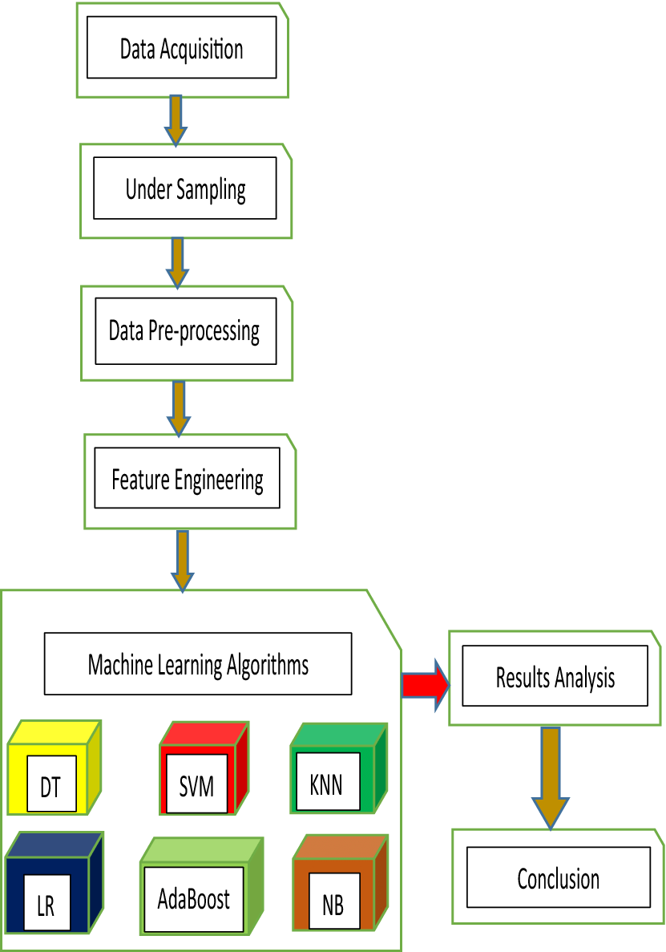

**Fig 4.1**

**4.2 UML Diagrams**

#### **4.2.1 Use case diagram**

Use Case during requirement elicitation and analysis to represent the functionality of the system. Use case describes a function by the system that yields a visible result for an actor. The identification of actors and use cases result in the definitions of the boundary of the system i.e., differentiating the tasks accomplished by the system and the tasks accomplished by its environment.

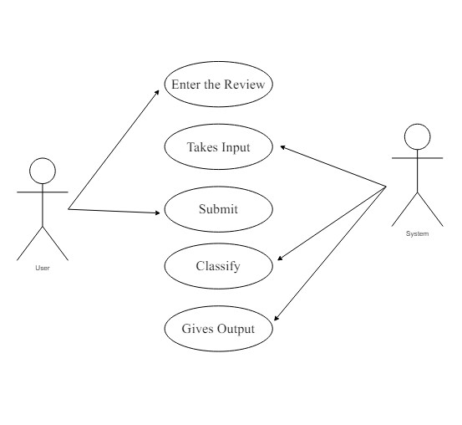

**Fig 4.2 (a)**

9

#### **4.2.2 Activity Diagram**

The process flows in the system are captured in the activity diagram. Similar to a state diagram, an activity diagram also consists of activities, actions, transitions, initial and final states, and guard conditions.

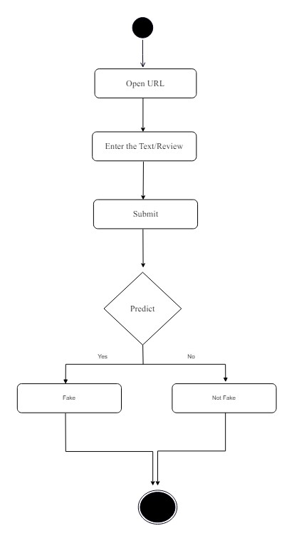

**Fig 4.2(b)**

**CHAPTER-5**

#### 

#### **5. IMPLEMENTATION**

**5.1: Code**

**App.py**

from flask import Flask, jsonify, render_template, request

import numpy as np

import pandas as pd

import sklearn as sk

import pickle

from sklearn.feature_extraction.text import CountVectorizer

from sklearn.naive_bayes import MultinomialNB, GaussianNB

from sklearn.model_selection import train_test_split

app = Flask(_name_)

model=pickle.load(open('model.pkl','rb'))

@app.route('/')

def root():

return render_template('index.html')

@app.route('/predict', methods=['GET','POST'])

def predict():

df = pd.read_csv('deceptive-opinion.csv')

df1 = df[['deceptive', 'text']]

df1.loc[df1['deceptive'] == 'deceptive', 'deceptive'] = 0

df1.loc[df1['deceptive'] == 'truthful', 'deceptive'] = 1

X = df1['text']

Y = np.asarray(df1['deceptive'], dtype = int)

X_train, X_test, y_train, y_test = train_test_split(X, Y, test_size=0.3,random_state=109)

cv = CountVectorizer()

x = cv.fit_transform(X_train)

y = cv.transform(X_test)

message = request.form.get('enteredinfo')

data = [message]

vect = cv.transform(data).toarray()

pred = model.predict(vect)

return render_template('result.html', prediction_text=pred)

if _name_ == '_main_':

app.run(debug=True)

**Index.html**

<!doctype html>

<html lang="en">

<head>

<!-- Required meta tags -->

<meta charset="utf-8">

<meta name="viewport" content="width=device-width, initial-scale=1, shrink-to-fit=no">

<!-- fontawesome -->

<script src="https://kit.fontawesome.com/106dacd3a9.js" crossorigin="anonymous"></script>

<!-- google fonts -->

<link href="https://fonts.googleapis.com/css2?family=Passion+One:wght@700&display=swap" rel="stylesheet">

<link href="https://fonts.googleapis.com/css2?family=Carter+One&display=swap" rel="stylesheet">

<link href="https://fonts.googleapis.com/css2?family=Raleway:wght@400;500;600;700;800&display=swap" rel="stylesheet">

<!-- Bootstrap CSS -->

<link rel="stylesheet" href="https://stackpath.bootstrapcdn.com/bootstrap/4.5.2/css/bootstrap.min.css"

integrity="sha384-JcKb8q3iqJ61gNV9KGb8thSsNjpSL0n8PARn9HuZOnIxN0hoP+VmmDGMN5t9UJ0Z" crossorigin="anonymous">

<!-- css -->

<link rel="stylesheet" href="static/styles.css">

<title>TEAM-21 | Fake Review Detection</title>

</head>

<body class="d-flex flex-column" tabindex="0">

<header class="text-light bg-dark">

<div class="container p-4">

<div class="heading text-center">

<span class="heading-logo p-1">TEAM-21</span>

</div>

</div>

</header>

<div class="main pt-5 text-center">

<span class="project-heading display-4 text-light p-3">Fake Review Detection</span>

<form action="{{ url_for('predict')}}" method="post">

<textarea name="enteredinfo" id="" placeholder="Enter the review..." class="mt-3"></textarea>

<div class="mt-3">

<button type="submit" class="btn btn-danger btn-lg">

<h3 class="mb-0 font-weight-bold">Submit</h3>

</button>

</div>

</form>

</div>

<footer class="footer text-light bg-dark py-4 text-center">

<div class="container">

<div class="footer-text">

<h2 class="font-weight-bold p-2">Made With <i class="fas fa-heart fa-lg" style="color: #dc3545;"></i></h2>

<h3 class="font-weight-bold mb-1">Developed By</h3>

<ul class="list-unstyled">

<li>Shirisha</li>

<li>Aamuktha</li>

<li>Uday Kiran</li>

</ul>

</div>

</div>

</footer>

<!-- Optional JavaScript -->

<!-- jQuery first, then Popper.js, then Bootstrap JS -->

<script src="https://code.jquery.com/jquery-3.5.1.slim.min.js"

integrity="sha384-DfXdz2htPH0lsSSs5nCTpuj/zy4C+OGpamoFVy38MVBnE+IbbVYUew+OrCXaRkfj"

crossorigin="anonymous"></script>

<script src="https://cdn.jsdelivr.net/npm/popper.js@1.16.1/dist/umd/popper.min.js"

integrity="sha384-9/reFTGAW83EW2RDu2S0VKaIzap3H66lZH81PoYlFhbGU+6BZp6G7niu735Sk7lN"

crossorigin="anonymous"></script>

<script src="https://stackpath.bootstrapcdn.com/bootstrap/4.5.2/js/bootstrap.min.js"

integrity="sha384-B4gt1jrGC7Jh4AgTPSdUtOBvfO8shuf57BaghqFfPlYxofvL8/KUEfYiJOMMV+rV"

crossorigin="anonymous"></script>

</body>

</html>

**Result.html:**

<!doctype html>

<html lang="en">

<head>

<!-- Required meta tags -->

<meta charset="utf-8">

<meta name="viewport" content="width=device-width, initial-scale=1, shrink-to-fit=no">

<!-- fontawesome -->

<script src="https://kit.fontawesome.com/106dacd3a9.js" crossorigin="anonymous"></script>

<!-- google fonts -->

<link href="https://fonts.googleapis.com/css2?family=Passion+One:wght@700&display=swap" rel="stylesheet">

<link href="https://fonts.googleapis.com/css2?family=Carter+One&display=swap" rel="stylesheet">

<link href="https://fonts.googleapis.com/css2?family=Raleway:wght@400;500;600;700;800&display=swap"

rel="stylesheet">

<!-- Bootstrap CSS -->

<link rel="stylesheet" href="https://stackpath.bootstrapcdn.com/bootstrap/4.5.2/css/bootstrap.min.css"

integrity="sha384-JcKb8q3iqJ61gNV9KGb8thSsNjpSL0n8PARn9HuZOnIxN0hoP+VmmDGMN5t9UJ0Z" crossorigin="anonymous">

<!-- css -->

<link rel="stylesheet" href="static/styles.css">

<title>Py-Tricksters | Fake Review Detection</title>

</head>

<body class="d-flex flex-column">

<header class="text-light bg-dark">

<div class="container p-4">

<div class="heading text-center">

<span class="heading-logo p-1">Py-Tricksters</span>

</div>

</div>

</header>

<div class="results" style="text-align: center; padding-top: 12%;">

{% if prediction_text == 1%}

<h2 class="heading-logo p-2" style="color:rgb(0,0,0);">Review is not fake💯</h2>

{% elif prediction_text == 0%}

<h2 class="heading-logo p-2" style="color:rgb(0,0,0);">Review is Fake☹</h2>

{% endif %}

</div>

<footer class="footer footer-result text-light bg-dark py-4 text-center">

<div class="container">

<div class="footer-text">

<h2 class="font-weight-bold p-2">Made With <i class="fas fa-heart fa-lg" style="color: #dc3545;"></i>

</h2>

<h3 class="font-weight-bold mb-1">Developed By</h3>

<ul class="list-unstyled">

<li>Shirisha</li>

<li>Aamuktha</li>

<li>Uday Kiran</li>

</ul>

</div>

</div>

</footer>

<!-- Optional JavaScript -->

<!-- jQuery first, then Popper.js, then Bootstrap JS -->

<script src="https://code.jquery.com/jquery-3.5.1.slim.min.js"

integrity="sha384-DfXdz2htPH0lsSSs5nCTpuj/zy4C+OGpamoFVy38MVBnE+IbbVYUew+OrCXaRkfj"

crossorigin="anonymous"></script>

<script src="https://cdn.jsdelivr.net/npm/popper.js@1.16.1/dist/umd/popper.min.js"

integrity="sha384-9/reFTGAW83EW2RDu2S0VKaIzap3H66lZH81PoYlFhbGU+6BZp6G7niu735Sk7lN"

crossorigin="anonymous"></script>

<script src="https://stackpath.bootstrapcdn.com/bootstrap/4.5.2/js/bootstrap.min.js"

integrity="sha384-B4gt1jrGC7Jh4AgTPSdUtOBvfO8shuf57BaghqFfPlYxofvL8/KUEfYiJOMMV+rV"

crossorigin="anonymous"></script>

</body>

</html>

**5.2: Output Screens:**

The interface:

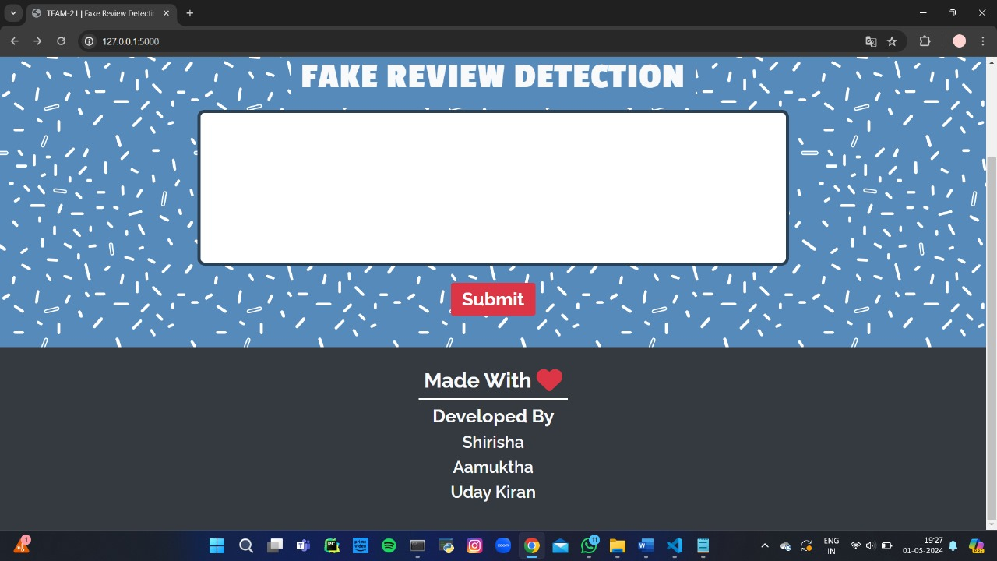

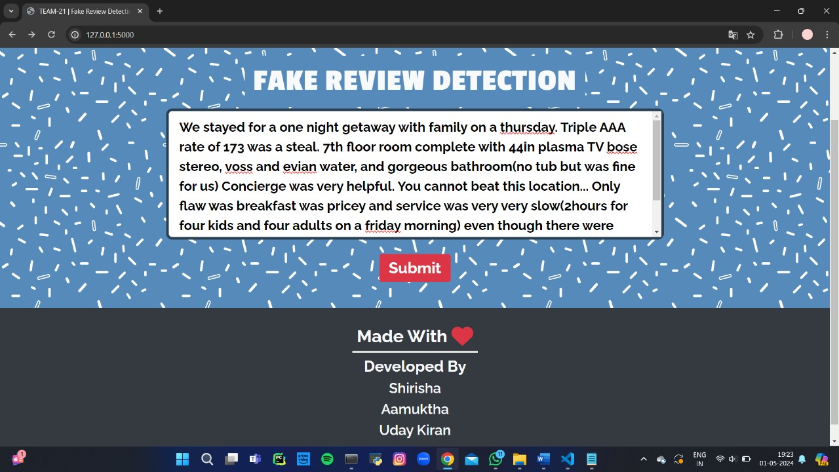

18

19



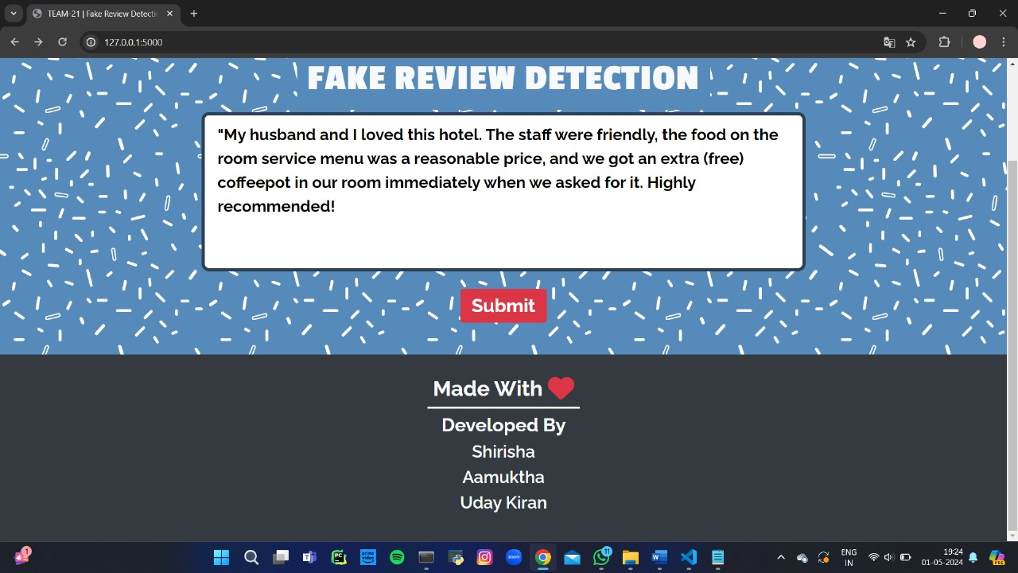



**CHAPTER 6**

**CONCLUSION & FUTURE SCOPE**

**6.1 CONCLUSION**

Detecting fake reviews is crucial for maintaining the integrity of online platforms. By implementing advanced algorithms and AI-driven systems, platforms can effectively identify and remove fraudulent reviews. However, continuous improvement and adaptation are necessary to stay ahead of evolving tactics used by malicious actors. Additionally, educating consumers about the prevalence of fake reviews and how to spot them can empower them to make more informed purchasing decisions. Ultimately, a collaborative effort between platforms, consumers, and regulatory bodies is essential in combating the proliferation of fake reviews in the digital space.

**6.2 Future scope**

In the future, the landscape of fake review detection is poised for significant advancements driven by cutting-edge technologies and collaborative efforts. With the continued evolution of artificial intelligence and data analytics, advanced AI models will become more adept at identifying subtle patterns and linguistic cues indicative of fraudulent reviews. Additionally, the integration of multimodal analysis, behavioral analytics, and blockchain technology will bolster the resilience of detection systems against sophisticated manipulation tactics. Moreover, there will be a greater emphasis on crowdsourced verification and user education to enlist the support of consumers in the fight against fake reviews. By fostering collaboration among online platforms, industry stakeholders, and regulatory bodies, the future holds promise for more robust and comprehensive strategies to combat the proliferation of fake reviews in the digital realm.

**CHAPTER 7**

**BIBILOGRAPHY**

[1] <https://www.geeksforgeeks.org/>

[2] <https://www.javatpoint.com/fake-news-detection-using-machine-learning>

[3] S. Tadelis, “The economics of reputation and feedback systems in ecommerce marketplaces,” IEEE Internet Computing, vol. 20, no. 1, pp. 12–19, 2016.

[4] M. J. H. Mughal, “Data mining: Web data mining techniques, tools and algorithms: An overview,” Information Retrieval, vol. 9, no. 6, 2018.

[5] C. C. Aggarwal, “Opinion mining and sentiment analysis,” in Machine Learning for Text. Springer, 2018, pp. 413–434.

[6] A. Mukherjee, V. Venkataraman, B. Liu, and N. Glance, “What yelp fake review filter might be doing?” in Seventh international AAAI conference on weblogs and social media, 2013.

[7] N. Jindal and B. Liu, “Review spam detection,” in Proceedings of the 16th International Conference on World Wide Web, ser. WWW ’07, 2007.

[8] E. Elmurngi and A. Gherbi, Detecting Fake Reviews through Sentiment Analysis Using Machine Learning Techniques. IARIA/DATA ANALYTICS, 2017.

[9] V. Singh, R. Piryani, A. Uddin, and P. Waila, “Sentiment analysis of movie reviews and blog posts,” in Advance Computing Conference (IACC), 2013, pp. 893–898.